Aim: - To write C++ code of the given following tasks.

Software Used: -

Cloud Keil Studio IDE and Tera Term

Theory: -

The mbed NXP LPC11U24 Microcontroller in particular is designed for prototyping low-cost USB devices, battery powered applications and 32-bit ARM® Cortex™-M0 based designs. It is packaged as a small DIP form-factor for prototyping with through-hole PCBs, stripboard and breadboard, and includes a built-in USB FLASH programmer.

Specifications of LPC11U24:

* NXP LPC11U24 MCU
* Low power ARM® Cortex™-M0 Core
* 48MHz, 8KB RAM, 32KB FLASH
* USB Device, 2xSPI, I2C, UART, 6xADC, GPIO
* Prototyping form-factor
* 40-pin 0.1" pitch DIP package, 54x26mm
* 5V USB, 4.5-9V supply or 2.4-3.3V battery
* Built-in USB drag 'n' drop FLASH programmer
* mbed.org Developer Website
* Lightweight Online Compiler
* High level C/C++ SDK
* Cookbook of published libraries and projects

API Used:

* Syntax used for digital output:
* DigitalOut (PinName pin)
* For LED blinking we’ve used:
* DigitalOut variable(LEDn); where n= 1,2,3,4
* For delay:
* wait(t); where ‘t’ is in seconds

Task 1: -

Code: -

#include "mbed.h"

Serial pc (USBTX,USBRX);

I2C i2c(PB_9, PB_8);

int main()

{

    int address = 0xA0;

    char data[100];

    pc.printf("Enter data to be sent: ");

    pc.scanf("%s",&data);

    //pc.printf("%s",data);

    int l=strlen(data);

    i2c.write(address, data, l);

    wait(1);

}

#include <mbed.h>

Serial pc(USBTX, USBRX);

I2CSlave slave(p28, p27);

intmain()

{charbuf[20];

charmsg[] = "Slave!";

slave.address(0xA0);

while (1) {

    Inti= slave.receive();

    switch (i)

    {case I2CSlave::ReadAddressed:slave.write(msg, strlen(msg) + 1); // Includes null charbreak;case I2CSlave::WriteGeneral:slave.read(buf, 20);

pc.printf("Read : %s\n", buf);

break;case I2CSlave::WriteAddressed:slave.read(buf, 20);pc.printf("Read : %s\n", buf);break;}for(inti= 0; i< 20; i++) buf[i] = 0;}}

Output: -

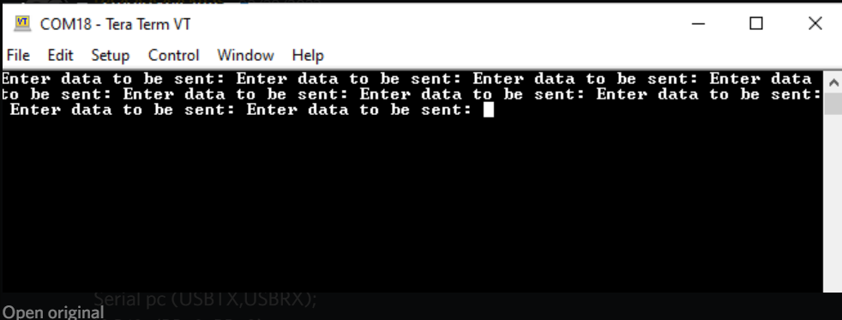

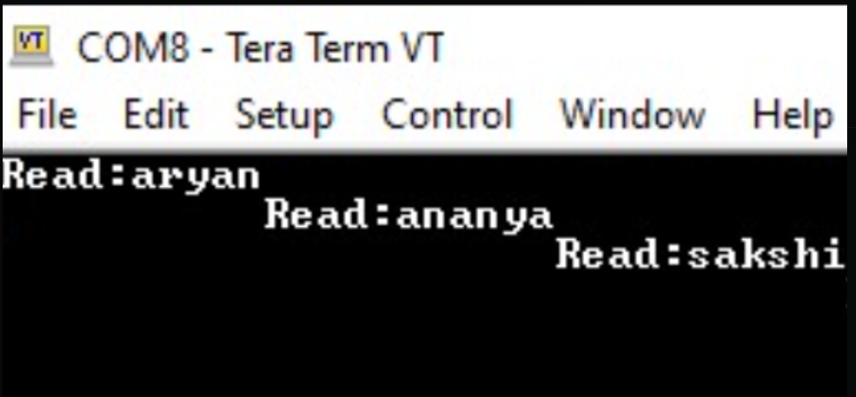

Verification Status: -

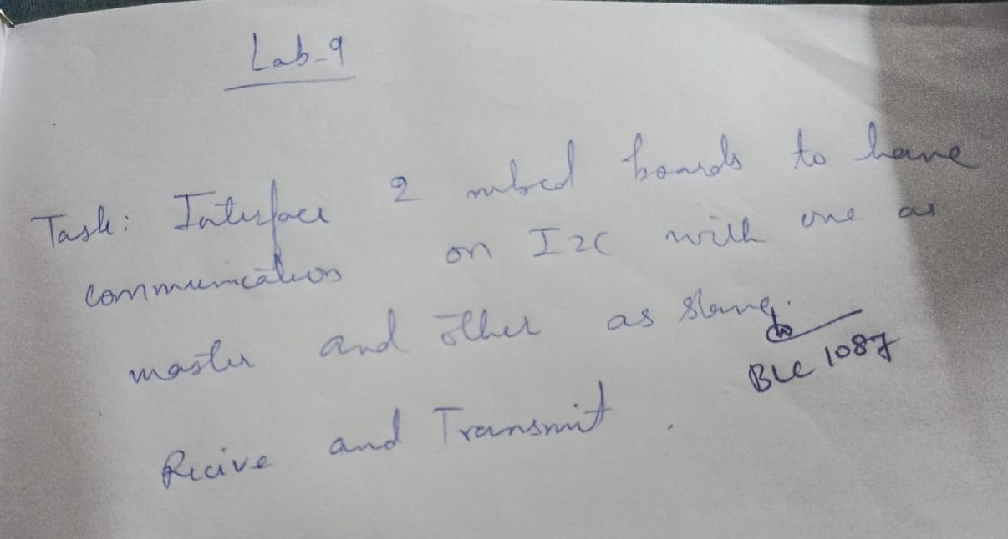

Result: -

Successfully understood and performed all the given tasks.